Cylindrical Surface

Definition
# Source: AI Source: Provided by: [Data Path: Persons Table -> ID Column: 1, Name_En Column: Motasem Essam] -> From: [ChatGPT] on [7/20/2026]
A Cylindrical Surface is a curved surface in three-dimensional space generated by a straight line moving parallel to a fixed direction while following a fixed curve.
In the most common circular case, a cylindrical surface consists of all points at a fixed perpendicular distance $r$from a central axis.
A circular cylindrical surface can be described as the lateral surface of a cylinder without its two circular bases.
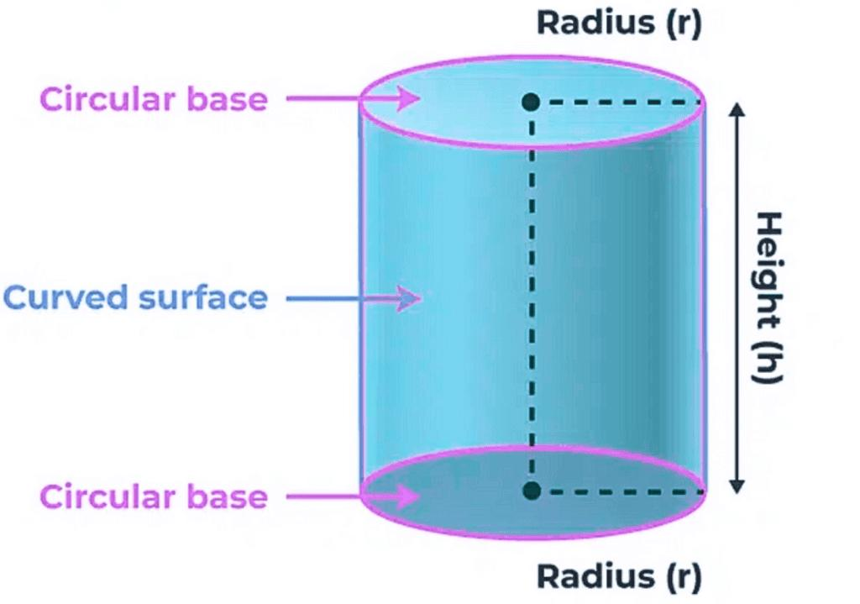
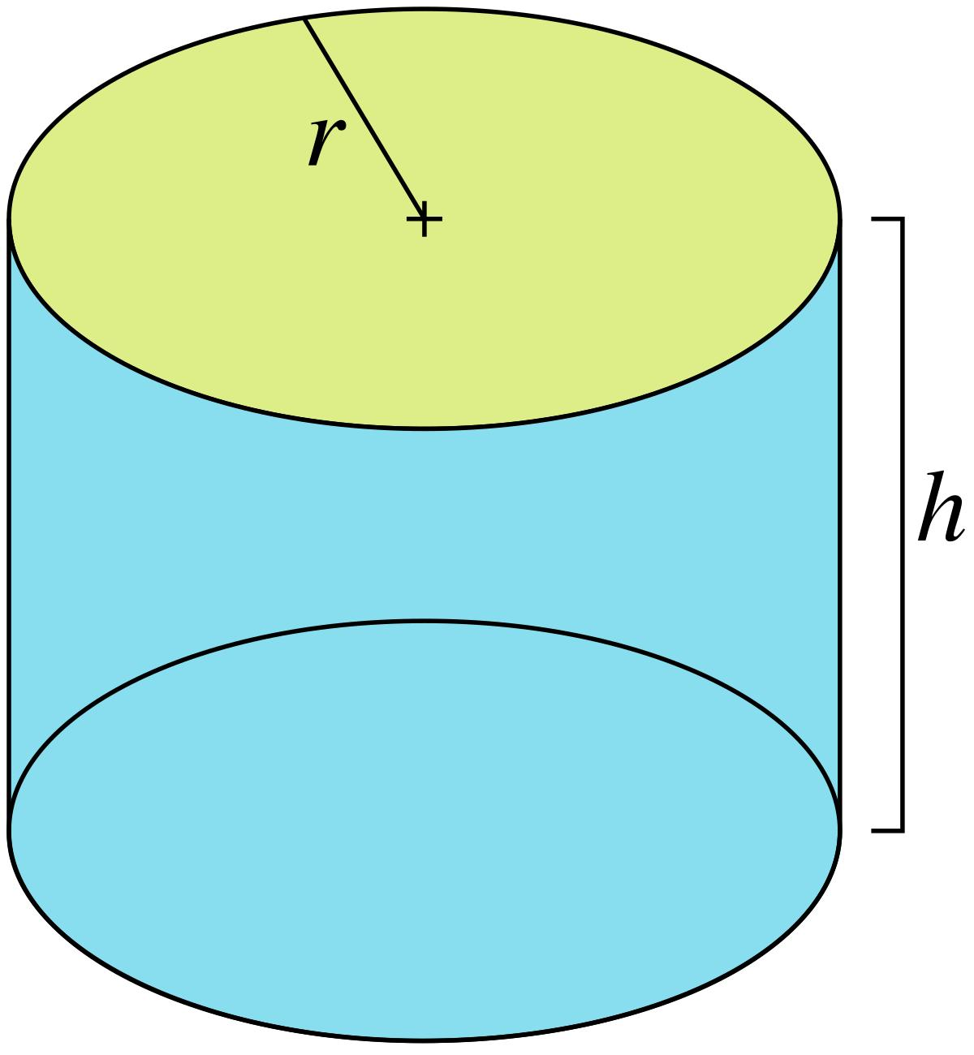
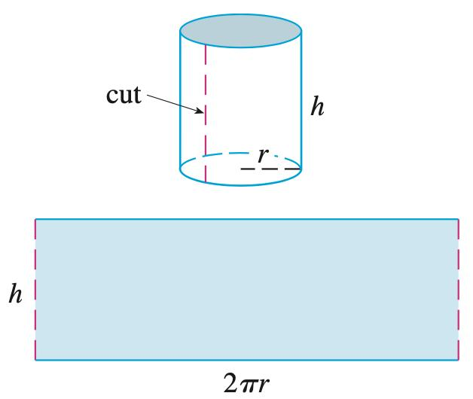
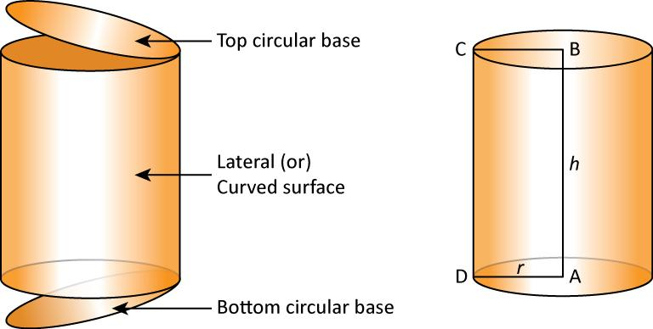
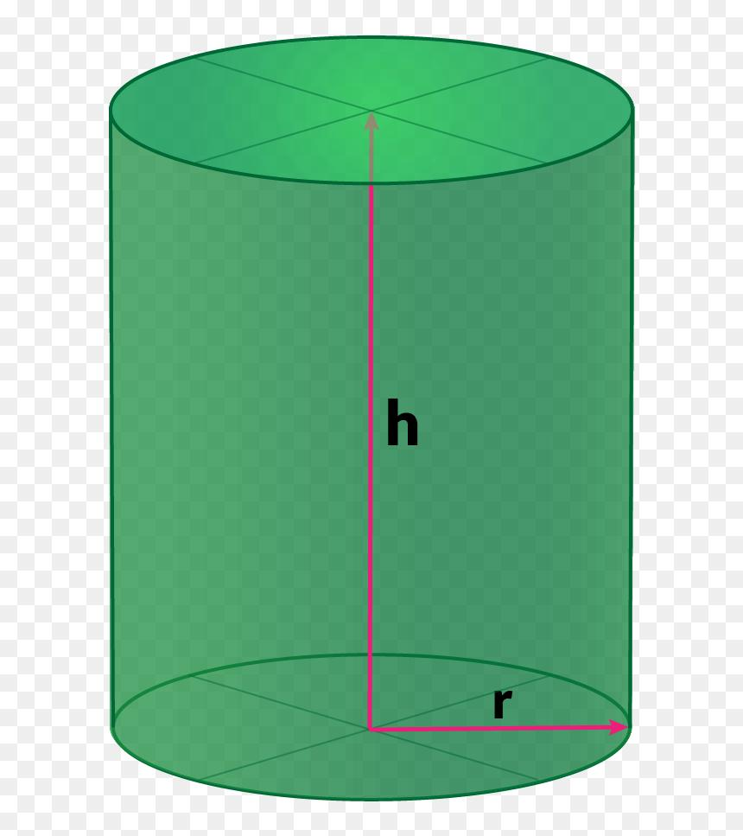

Purpose
# Source: AI Source: Provided by: [Data Path: Persons Table -> ID Column: 1, Name_En Column: Motasem Essam] -> From: [ChatGPT] on [7/20/2026]
A cylindrical surface is used to:
- Describe the curved boundary of a cylinder.
- Calculate curved surface area.
- Model curved objects in three-dimensional geometry.
- Study surfaces generated by parallel lines.
- Represent pipes, tubes, tanks, columns, and other cylindrical structures.
- Connect geometry with coordinate geometry and surface equations.

Fundamental Elements
# Source: AI Source: Provided by: [Data Path: Persons Table -> ID Column: 1, Name_En Column: Motasem Essam] -> From: [ChatGPT] on [7/20/2026]
For a circular cylindrical surface, the main elements are:

1. Axis
# Source: AI Source: Provided by: [Data Path: Persons Table -> ID Column: 1, Name_En Column: Motasem Essam] -> From: [ChatGPT] on [7/20/2026]
The axis is the fixed straight line around which the circular cylindrical surface is arranged.

2. Radius
# Source: AI Source: Provided by: [Data Path: Persons Table -> ID Column: 1, Name_En Column: Motasem Essam] -> From: [ChatGPT] on [7/20/2026]
The radius $r$is the perpendicular distance from the axis to the cylindrical surface.

3. Height
# Source: AI Source: Provided by: [Data Path: Persons Table -> ID Column: 1, Name_En Column: Motasem Essam] -> From: [ChatGPT] on [7/20/2026]
The height $h$is the distance measured parallel to the axis between two boundary circles of a finite cylindrical surface.

4. Generators
# Source: AI Source: Provided by: [Data Path: Persons Table -> ID Column: 1, Name_En Column: Motasem Essam] -> From: [ChatGPT] on [7/20/2026]
A generator is a straight line segment lying on the cylindrical surface and parallel to the axis.
For a right circular cylinder, the generators are perpendicular to the circular bases.

5. Directrix
# Source: AI Source: Provided by: [Data Path: Persons Table -> ID Column: 1, Name_En Column: Motasem Essam] -> From: [ChatGPT] on [7/20/2026]
The directrix is the curve followed by the generator. For a circular cylinder, the directrix is a circle.

Mathematical Representation
# Source: AI Source: Provided by: [Data Path: Persons Table -> ID Column: 1, Name_En Column: Motasem Essam] -> From: [ChatGPT] on [7/20/2026]
Circular Cylindrical Surface
For a cylinder whose axis is the $z$-axis:
$$x^{2}+y^{2}=r^{2}$$
Notice that there is no $z$in this equation.
This means the same circular cross-section exists at every height along the $z$-axis.
For a finite cylinder of height $h$:
$$0≤z≤h$$
so the complete lateral surface can be represented by:
$$x^{2}+y^{2}=r^{2}, 0≤z≤h$$

Curved Surface Area
# Source: AI Source: Provided by: [Data Path: Persons Table -> ID Column: 1, Name_En Column: Motasem Essam] -> From: [ChatGPT] on [7/20/2026]
The Curved Surface Area (CSA) of a right circular cylinder is:
$$\boxed{CSA=2πrh}$$
where:
- $r$= radius
- $h$= height
This formula calculates only the curved part and does not include the circular bases.
Total Surface Area
If the two circular bases are included:
$$\boxed{TSA=2πrh+2πr^{2}}$$
or:
$$\boxed{TSA=2πr\left(h+r\right)}$$

Why the Formula is $2πrh$
# Source: AI Source: Provided by: [Data Path: Persons Table -> ID Column: 1, Name_En Column: Motasem Essam] -> From: [ChatGPT] on [7/20/2026]
Imagine cutting the cylindrical surface vertically and unfolding it.
The curved surface becomes a rectangle.
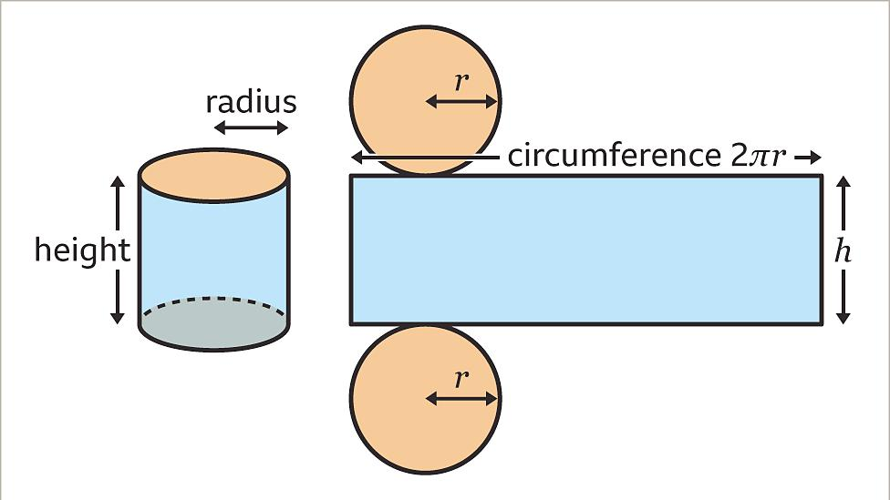
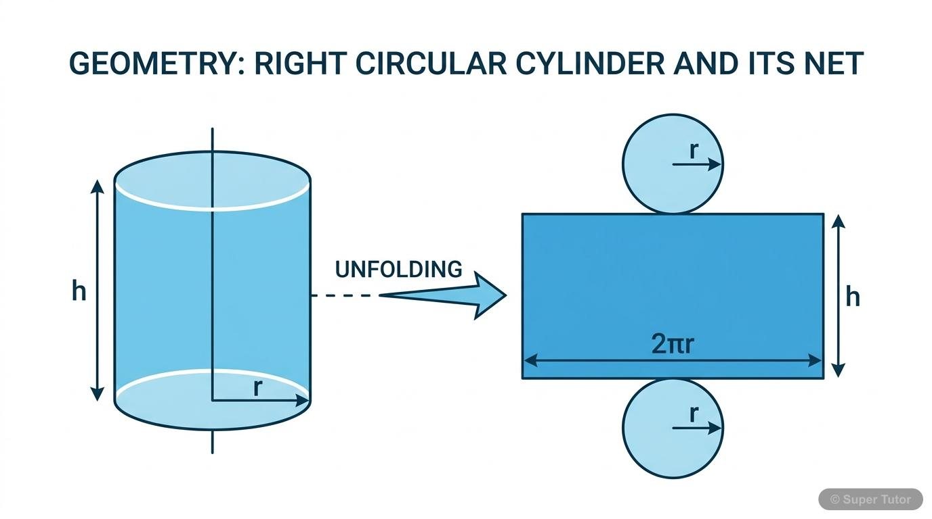
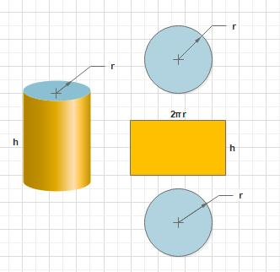
The rectangle has:
- Width = circumference of the circular base:
$$2πr$$
- Height = $h$
Therefore:
$$CSA=\left(2πr\right)\left(h\right)$$
so:
$$\boxed{CSA=2πrh}$$

Main Properties
# Source: AI Source: Provided by: [Data Path: Persons Table -> ID Column: 1, Name_En Column: Motasem Essam] -> From: [ChatGPT] on [7/20/2026]
A cylindrical surface has the following properties:
- It is a curved surface.
- A circular cylindrical surface has constant radius.
- Its generators are straight and parallel to the axis.
- A complete finite cylindrical lateral surface has two circular boundary curves.
- It has no vertices.
- It has no sharp edges on the lateral surface itself.
- Its curvature is zero in the direction parallel to the axis.
- Its curvature is nonzero in the direction around the cylinder.
- The lateral surface of a finite cylinder is an open surface.
- If the two circular bases are added, the resulting complete cylinder boundary becomes a closed surface.

Open and Closed Cylindrical Surfaces
# Source: AI Source: Provided by: [Data Path: Persons Table -> ID Column: 1, Name_En Column: Motasem Essam] -> From: [ChatGPT] on [7/20/2026]
It is important to distinguish the cylindrical surface from the complete surface of a cylinder.
Cylindrical Lateral Surface
$$\boxed{x^{2}+y^{2}=r^{2}, 0≤z≤h}$$
without the two circular bases.
It is an open surface.
Complete Cylinder Surface
The lateral surface plus the two circular bases:
$$x^{2}+y^{2}=r^{2}, 0≤z≤h$$
together with:
$$z=0, x^{2}+y^{2}≤r^{2}$$
and:
$$z=h, x^{2}+y^{2}≤r^{2}$$
This forms a closed surface.

Examples

Example 1: Finding Curved Surface Area
# Source: AI Source: Provided by: [Data Path: Persons Table -> ID Column: 1, Name_En Column: Motasem Essam] -> From: [ChatGPT] on [7/20/2026]
A cylindrical surface has radius $r=5\text{ cm}$and height $h=10\text{ cm}$.
Using:
$$CSA=2πrh \\ CSA=2π\left(5\right)\left(10\right) \\ \boxed{CSA=100π{\text{ cm}}^{2}}$$
Approximately:
$$\boxed{CSA≈314.16{\text{ cm}}^{2}}$$

Example 2: Finding the Radius
# Source: AI Source: Provided by: [Data Path: Persons Table -> ID Column: 1, Name_En Column: Motasem Essam] -> From: [ChatGPT] on [7/20/2026]
A cylindrical surface has curved surface area $120π{\text{ cm}}^{2}$and height $10\text{ cm}$.
$$120π=2πrh$$
Substitute $h=10$:
$$120π=2πr\left(10\right) \\ 120π=20πr \\ r=6$$
Therefore:
$$\boxed{r=6\text{ cm}}$$

Example 3: Finding the Height
# Source: AI Source: Provided by: [Data Path: Persons Table -> ID Column: 1, Name_En Column: Motasem Essam] -> From: [ChatGPT] on [7/20/2026]
Suppose:
$$CSA=160π{\text{ cm}}^{2}$$
and:
$$r=8\text{ cm}$$
Using:
$$160π=2π\left(8\right)h \\ 160π=16πh \\ h=10$$
Therefore:
$$\boxed{h=10\text{ cm}}$$

Types of Cylindrical Surfaces
# Source: AI Source: Provided by: [Data Path: Persons Table -> ID Column: 1, Name_En Column: Motasem Essam] -> From: [ChatGPT] on [7/20/2026]
Cylindrical surfaces can be classified in several ways.

1. Circular Cylindrical Surface
# Source: AI Source: Provided by: [Data Path: Persons Table -> ID Column: 1, Name_En Column: Motasem Essam] -> From: [ChatGPT] on [7/20/2026]
The directrix is a circle.
Example:
$$x^{2}+y^{2}=r^{2}$$
This is the most common cylindrical surface studied in elementary geometry.

2. Right Circular Cylindrical Surface
# Source: AI Source: Provided by: [Data Path: Persons Table -> ID Column: 1, Name_En Column: Motasem Essam] -> From: [ChatGPT] on [7/20/2026]
The axis is perpendicular to the circular base.

3. Oblique Cylindrical Surface
# Source: AI Source: Provided by: [Data Path: Persons Table -> ID Column: 1, Name_En Column: Motasem Essam] -> From: [ChatGPT] on [7/20/2026]
The generators are not perpendicular to the base.

4. General Cylindrical Surface
# Source: AI Source: Provided by: [Data Path: Persons Table -> ID Column: 1, Name_En Column: Motasem Essam] -> From: [ChatGPT] on [7/20/2026]
The directrix can be a curve other than a circle, while the generators remain parallel to a fixed direction.

Cylindrical Surface vs Cylinder
# Source: AI Source: Provided by: [Data Path: Persons Table -> ID Column: 1, Name_En Column: Motasem Essam] -> From: [ChatGPT] on [7/20/2026]
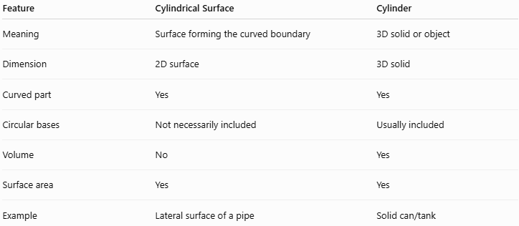
Feature | Cylindrical Surface | Cylinder
Meaning | Surface forming the curved boundary | 3D solid or object
Dimension | 2D surface | 3D solid
Curved part | Yes | Yes
Circular bases | Not necessarily included | Usually included
Volume | No | Yes
Surface area | Yes | Yes
Example | Lateral surface of a pipe | Solid can/tank
The distinction is important:
$$\boxed{\text{Cylindrical Surface}≠\text{Cylinder Solid}}$$
A cylindrical surface describes the boundary, while a cylinder can refer to the three-dimensional solid enclosed by that boundary.

Relationship with Other Surfaces
# Source: AI Source: Provided by: [Data Path: Persons Table -> ID Column: 1, Name_En Column: Motasem Essam] -> From: [ChatGPT] on [7/20/2026]
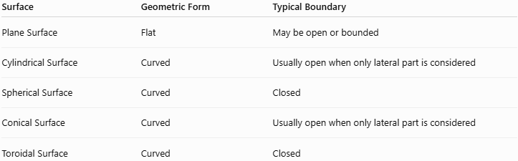
Surface | Geometric Form | Typical Boundary
Plane Surface | Flat | May be open or bounded
Cylindrical Surface | Curved | Usually open when only lateral part is considered
Spherical Surface | Curved | Closed
Conical Surface | Curved | Usually open when only lateral part is considered
Toroidal Surface | Curved | Closed
A cylindrical surface therefore belongs to:
$$\boxed{\text{Curved Surface}}$$
and a finite lateral cylindrical surface is also:
$$\boxed{\text{Open Surface}}$$

Real-World Applications
# Source: AI Source: Provided by: [Data Path: Persons Table -> ID Column: 1, Name_En Column: Motasem Essam] -> From: [ChatGPT] on [7/20/2026]
Cylindrical surfaces appear in:
- Pipes and tubes
- Water tanks
- Storage tanks
- Cans
- Columns
- Cylindrical buildings
- Rollers
- Shafts
- Machine components
- Bottles
- Barrels
- Tunnels
- Electrical cables
- Heat exchangers
For example, when calculating the amount of material needed to wrap the outside of a cylindrical pipe, the relevant geometric quantity is its curved surface area.

Advantages
# Source: AI Source: Provided by: [Data Path: Persons Table -> ID Column: 1, Name_En Column: Motasem Essam] -> From: [ChatGPT] on [7/20/2026]
- Provides a simple mathematical model for cylindrical objects.
- Has a straightforward surface-area formula.
- Can be unfolded into a rectangle for visualization.
- Has a simple coordinate equation for a circular cylinder.
- Useful in engineering, architecture, manufacturing, and physics.

Limitations
# Source: AI Source: Provided by: [Data Path: Persons Table -> ID Column: 1, Name_En Column: Motasem Essam] -> From: [ChatGPT] on [7/20/2026]
- The formula $2πrh$applies specifically to the lateral surface of a right circular cylinder.
- It does not include the circular bases.
- More general cylindrical surfaces may require parametric or differential-geometric descriptions.
- Real cylindrical objects may not be perfectly circular or straight.

Comparison with Spherical Surface
# Source: AI Source: Provided by: [Data Path: Persons Table -> ID Column: 1, Name_En Column: Motasem Essam] -> From: [ChatGPT] on [7/20/2026]
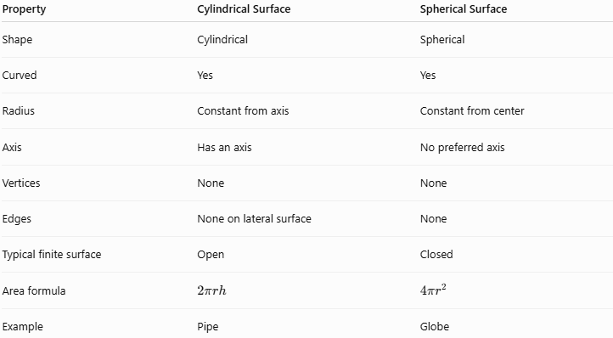
Property | Cylindrical Surface | Spherical Surface
Shape | Cylindrical | Spherical
Curved | Yes | Yes
Radius | Constant from axis | Constant from center
Axis | Has an axis | No preferred axis
Vertices | None | None
Edges | None on lateral surface | None
Typical finite surface | Open | Closed
Area formula | $$2πrh$$ | $$4πr^{2}$$
Example | Pipe | Globe

Key Points
# Source: AI Source: Provided by: [Data Path: Persons Table -> ID Column: 1, Name_En Column: Motasem Essam] -> From: [ChatGPT] on [7/20/2026]
- A cylindrical surface is a curved surface generated by parallel straight lines following a fixed directrix.
- A circular cylindrical surface has equation:
$$\boxed{x^{2}+y^{2}=r^{2}}$$
for an axis along the $z$-axis.
- Its curved surface area is:
$$\boxed{CSA=2πrh}$$
- A finite lateral cylindrical surface is open because its circular ends are not included.
- Adding the two circular bases produces a closed cylindrical surface.
- A cylindrical surface has an axis, radius, height, generators, and directrix.
- A cylindrical surface is a surface, not the same thing as a cylinder solid.
- Cylindrical surfaces are common in engineering, architecture, manufacturing, and everyday objects.

Conclusion
# Source: AI Source: Provided by: [Data Path: Persons Table -> ID Column: 1, Name_En Column: Motasem Essam] -> From: [ChatGPT] on [7/20/2026]
A Cylindrical Surface is one of the fundamental types of curved surfaces in geometry. It is characterized by parallel generators arranged around a fixed directrix; in the common circular case, every point on the surface is at a constant distance from a central axis. Its most important elementary formula is the curved surface area,
$$\boxed{CSA=2πrh}$$
and its classification demonstrates an important principle in geometry: geometric form and boundary properties are separate classifications. Thus, a cylindrical surface is a curved surface, while a finite lateral cylindrical surface is generally an open surface.

